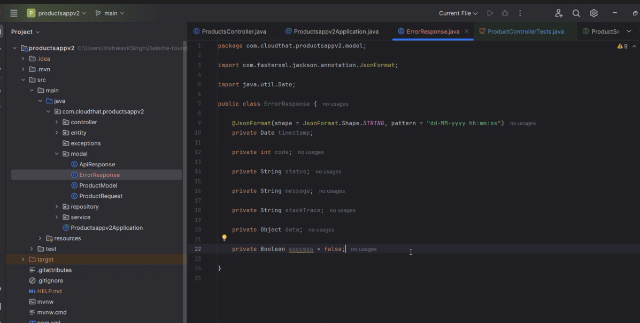

Generate getters and setters

For constructors one with setStackTrace and other without it.

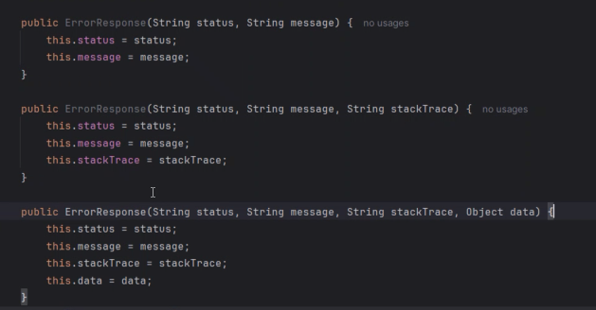

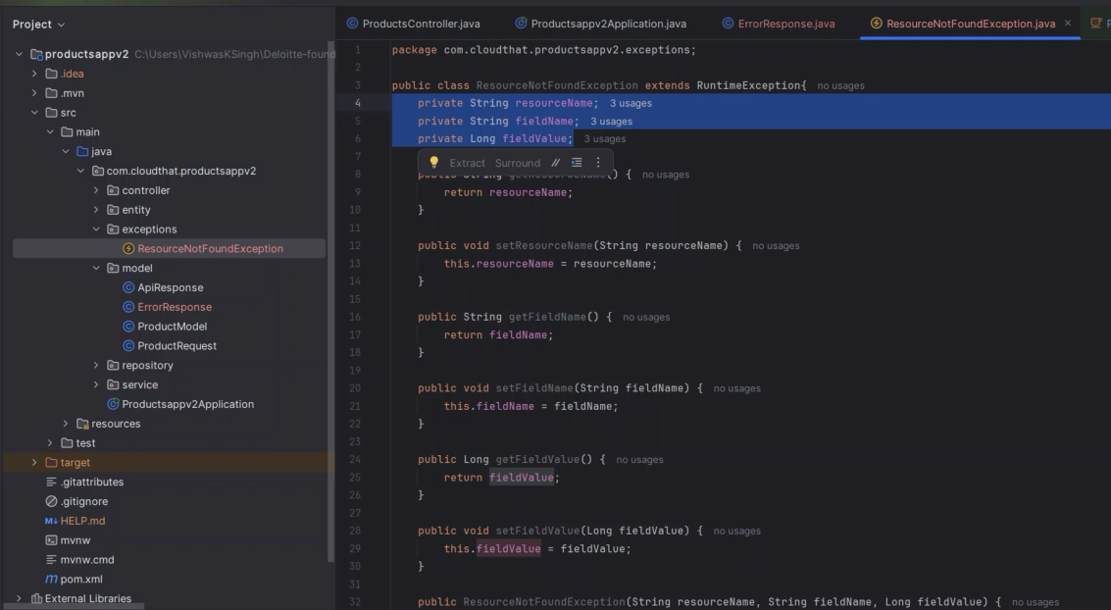

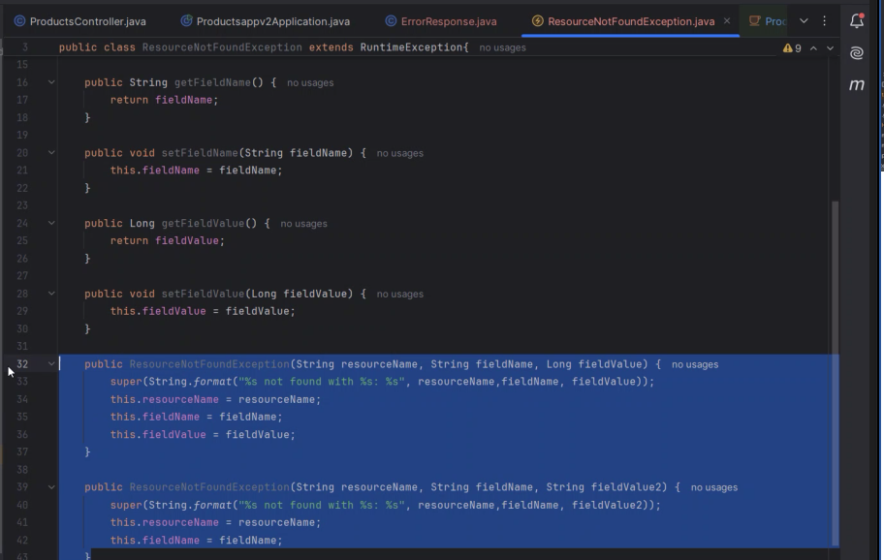

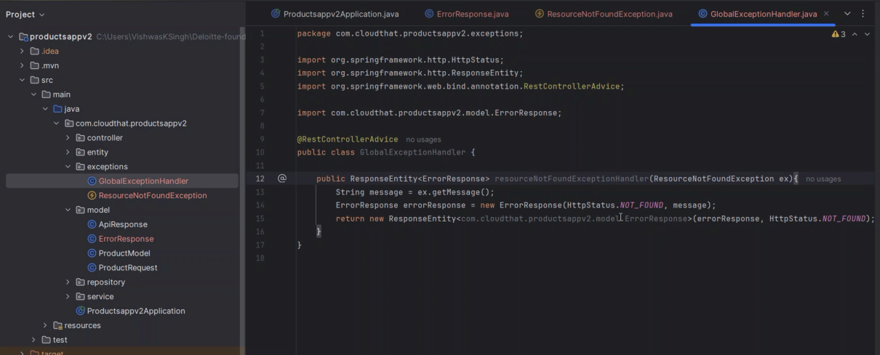

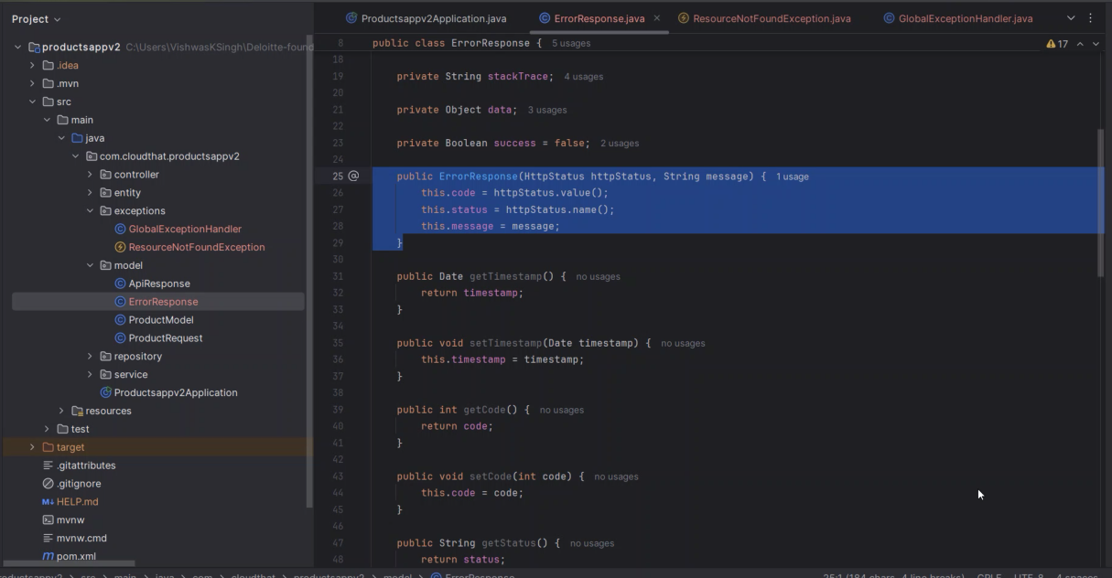

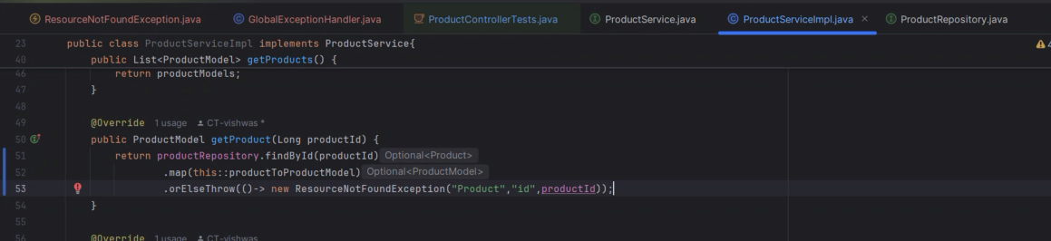

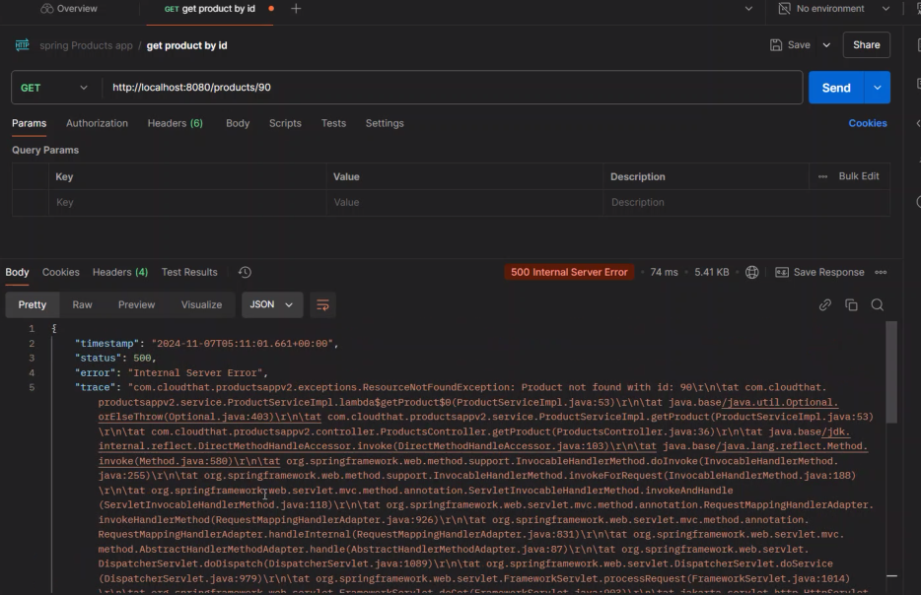

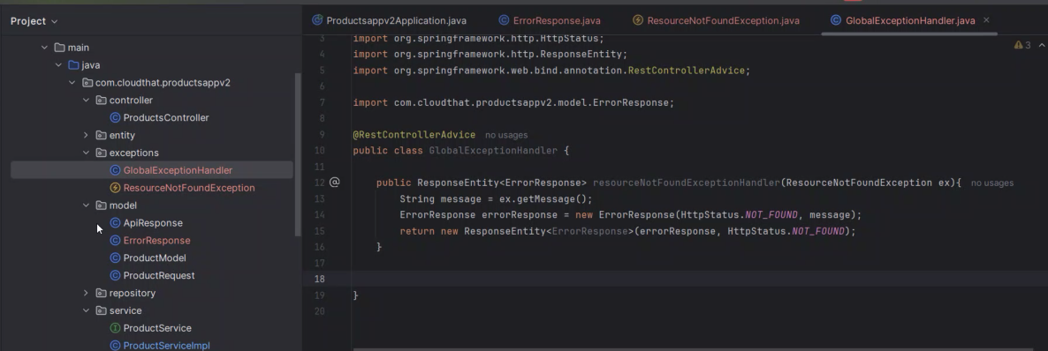

Good habit to have a fallback handler for the exception handler as an general exception handler.

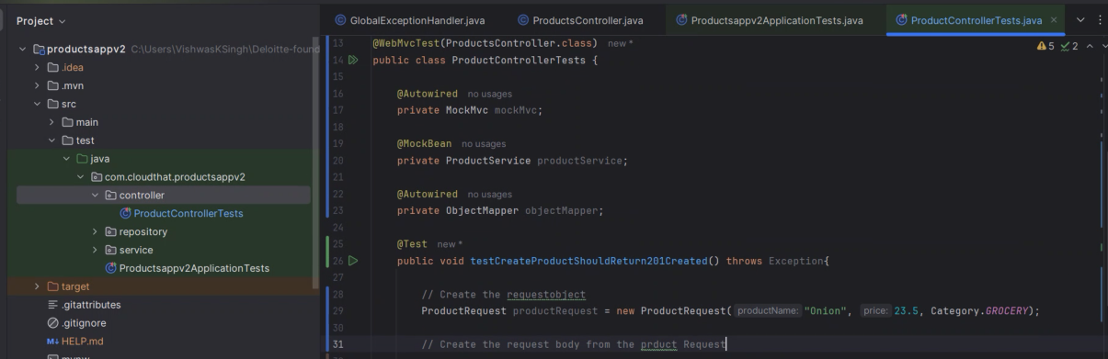

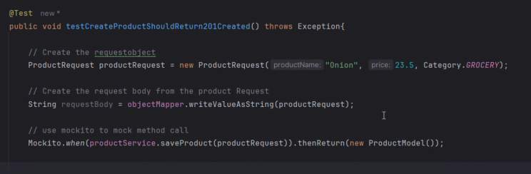

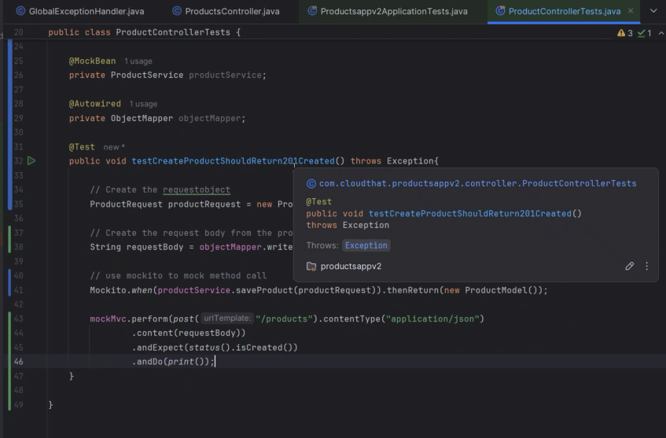

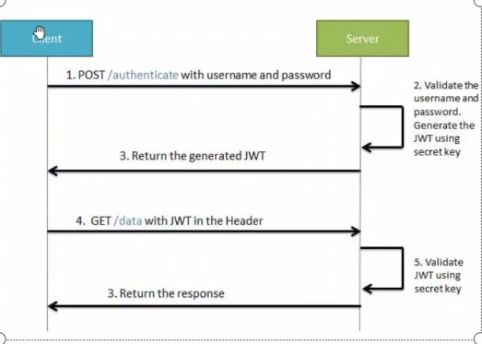

Generate new project

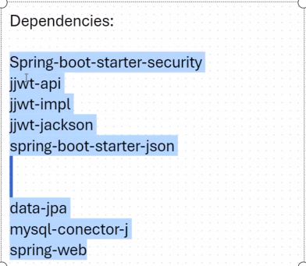

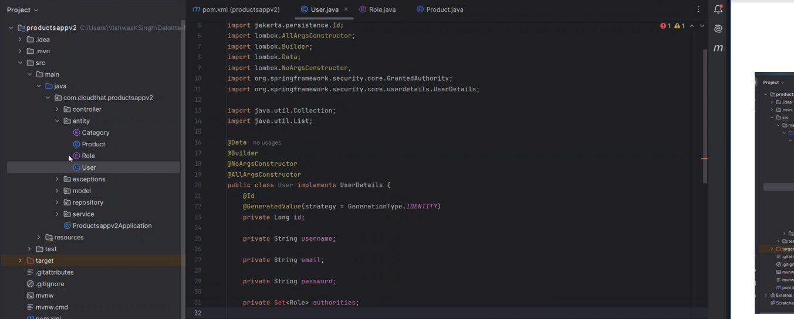

Created user class inmplments core hover over red lines and import those methods

Then based on the fields getauthority, getpasswrod etc.. I creted those fields

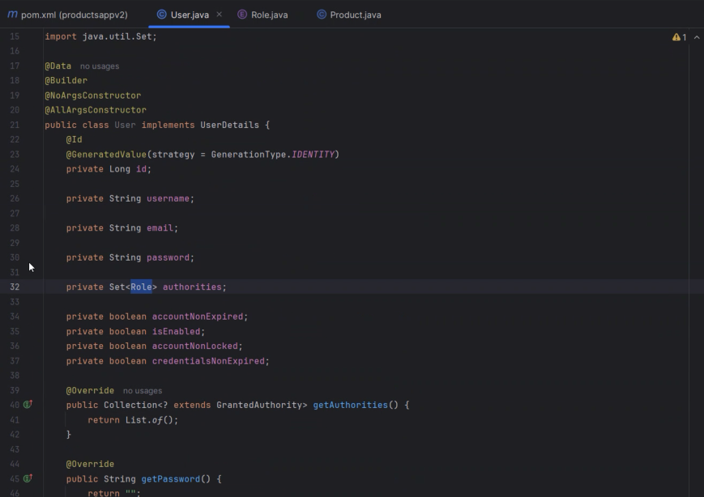

Erated an enum which grants authority and implemented the method getAuthority()

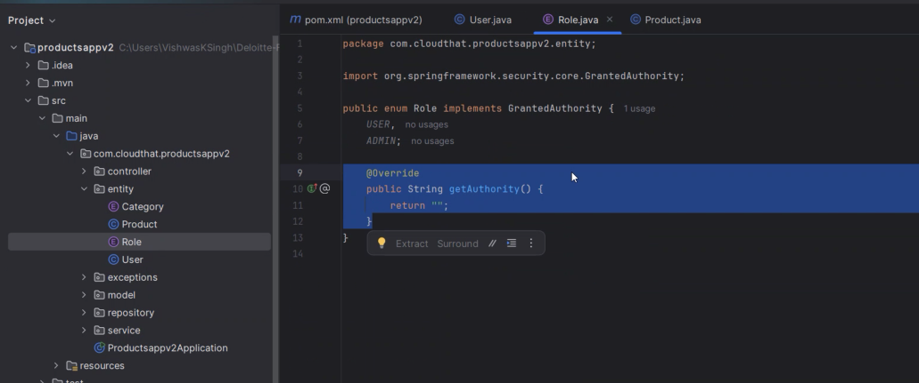

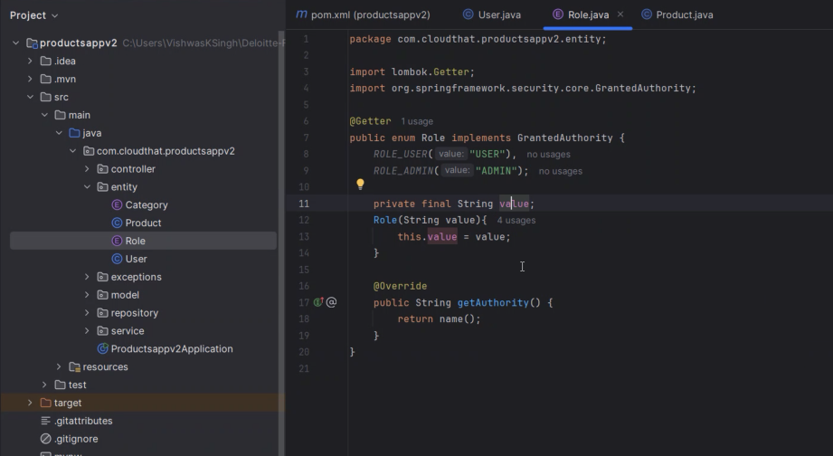

First need to include the security and json web token and all those other depens in pom.xml

Second create a user – fields of email,pass,role and authorities.

Create RegistrationController which follows the earlier flow

Implement the filter jwt filter which extends oncePerRequestFilter , may use utilities for generating token, expiration dta, checking the claims all those things u can implement in the utility.

Finally implement weSecurityConfig and autowire the userDataservice and jwtfilter

Create bean for authenticationManager

Last and final part is implement securtiyFIlterCahin in webseurityconfig.java class under config section